ASSIGNMENT -3
BLINKIND LED:
Program for Blinking Led:
void setup()
{
Serial.begin(9600);
pinMode(27, OUTPUT);
}

void loop()
{
digitalWrite (27,HIGH);
Serial.println("LED ON");
delay(1000);
digitalWrite (27,LOW);
Serial.println("LED OFF");
delay(1000);
}
Output:
Blinking LED For Rasberry pi :
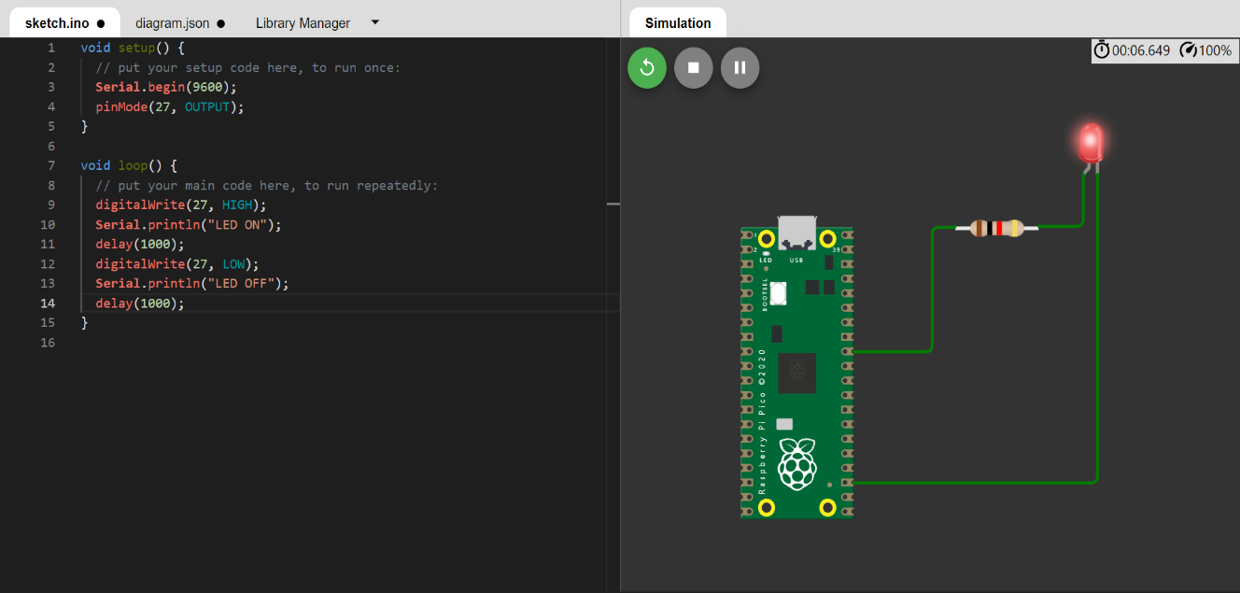
TRAFFIC LIGHT:
Program for traffic lights:
void setup()
{
Serial.begin(9600);
pinMode(21, OUTPUT);
pinMode(20, OUTPUT);
pinMode(19, OUTPUT);
}

void loop()
{
digitalWrite (21,HIGH);
delay(5000);
digitalWrite (21,LOW);
digitalWrite(20, HIGH);
delay(5000);
digitalWrite(20, LOW);
digitalWrite(19, HIGH);
delay(5000);
digitalWrite(19, LOW);
}

Output:
Traffic lights fo Raspberry pi
Blinking Red Light:
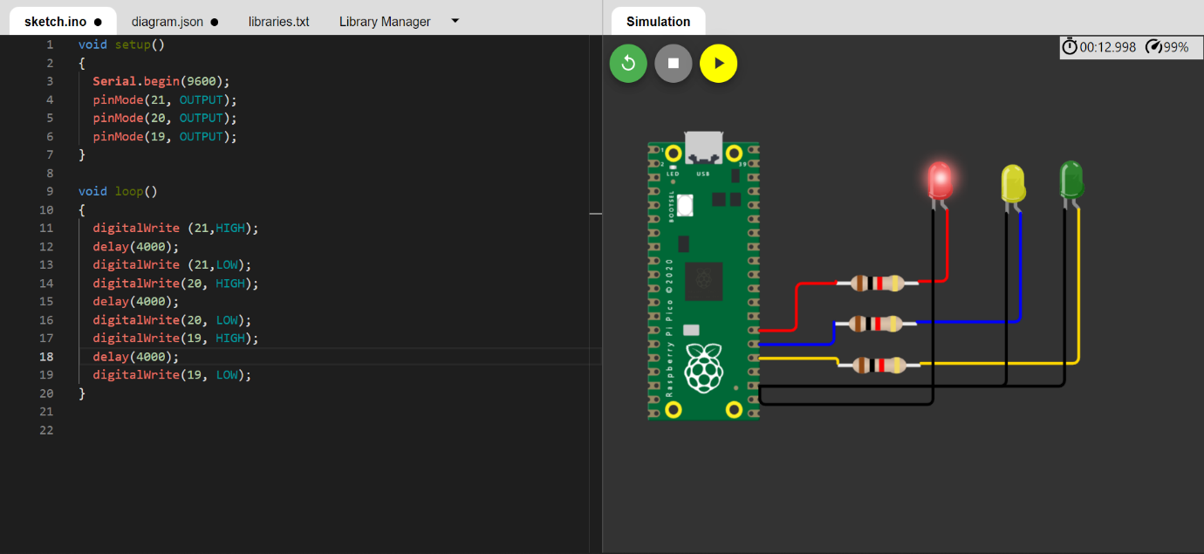

Blinking Yellow Light:
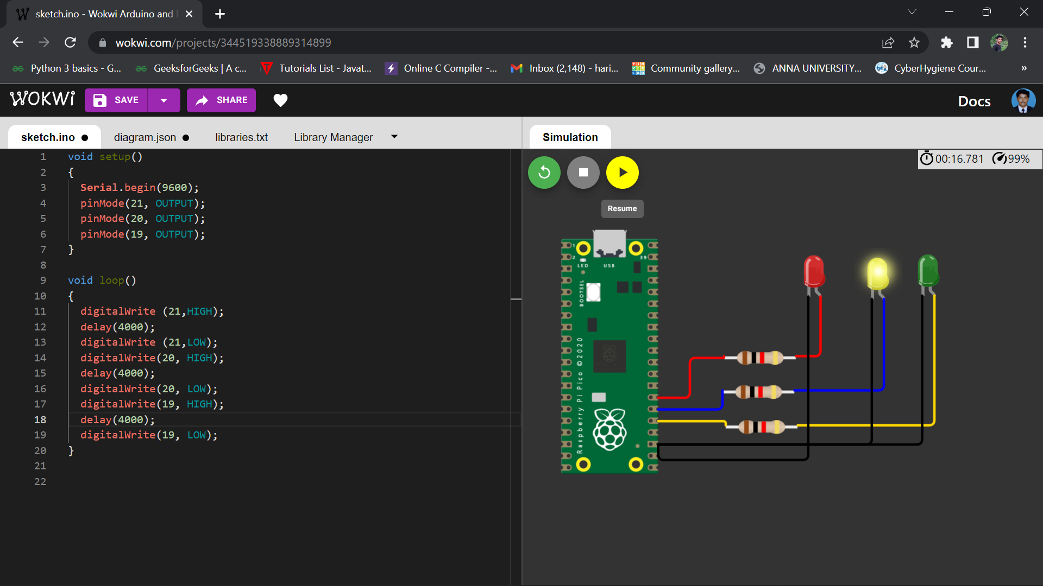

Blinking green Light:
